CSIT314 Software Development Methodologies - Group Project

Sprint 2 - US39: Platform manager log in
Interior Design Platform - Platform Manager
All diagrams were drawn in draw.io. Open "US39 Platform manager log in.drawio" in this folder to edit them - each diagram is its own page in that file. The exported images are in the "diagrams" folder.

Assumptions
- The system is the Interior Design Platform from the project specification. Sprint 2 covers the Interior Designer's log in, company profile and log out stories (US13 - US19) and the Platform Manager's log in, log out and IDP category stories (US39 - US45).
- A Platform Manager is a user account whose user profile is Active and has both the "Manage IDP categories" and "Generate reports" permissions (REQUIRED_MANAGER_PERMISSIONS). We check the permissions, not the profile name, so a custom profile with those two permissions can also log in.
- We follow B-C-E: the actor only talks to the boundary (page), the boundary only talks to the controller, and the controller works with the entity classes. There is one controller per use case.
- The page checks that both fields are filled in and trims the spaces from the username. PlatformManagerLoginController.login() makes one call: UserAccount().verifyCredentials(username, password, REQUIRED_MANAGER_PERMISSIONS). verifyCredentials() does every database check in one call: the password hash, the account status, the profile status and the permissions. Checking the role is allowed here because logging in is the use case itself.
- The platform manager's user account is made by the User Admin first (UC8). US39 reuses the existing UserAccount entity class (it reads the account's user_profile row itself), so no new table is needed.
- Platform Managers log in on their own page (/manager/login). The shared /login page (US1) is for User Admins only, so a platform manager gets the US1 error message there and has no User Admin session (the User Admin pages such as /accounts send them to /login).
- Every failed login shows the same message, so the page doesn't tell anyone whether the username exists or the account is suspended.
- When the login works, the old session is cleared and only userId, profileId and username are saved. The password is never saved in the session.
- The manager dashboard just renders - it doesn't check the account or profile again. managerLoginRequired in app.py only sends someone with no session to /manager/login.
- Platform manager log out is US40. The IDP Categories and Reports cards lead to US41 - US45 and US46 - US48.

1. User story
Story ID | US39
User story | As a platform manager, I want to log in so that I can manage IDP categories and reports.
Actor | Platform Manager
Priority | High
Story points (estimate) | 3
Acceptance criteria | 1. Given I open the manager login page, then I see a username and password form.  2. Given my username and password are correct and my account and profile are Active, when I click "Log in", then I go to the manager dashboard and see "Welcome back, <username>".  3. Given I leave the username or password empty, then I see "Please enter your username and password".  4. Given the password is wrong, the username doesn't exist, my account or profile is suspended, or my account is not a platform manager, then I see "Invalid login details or access unavailable" and I am not logged in.  5. The dashboard shows the IDP Categories and Reports cards, and none of the User Admin pages.  6. Given I am not logged in, when I open the manager dashboard, then I am sent to the manager login page.
Tasks | #133 Draw Platform Manager Login Use Case Diagram  #134 Write Platform Manager Login Use Case Description  #135 Draw Platform Manager Login BCE Diagram  #136 Draw Platform Manager Login Sequence Diagram  #137 Design Platform Manager Login Wireframe  #138 Write and Execute Platform Manager Login Test Cases

2. Use case diagram
The user story becomes one use case, UC39 Platform manager log in. The Platform Manager is the only actor.
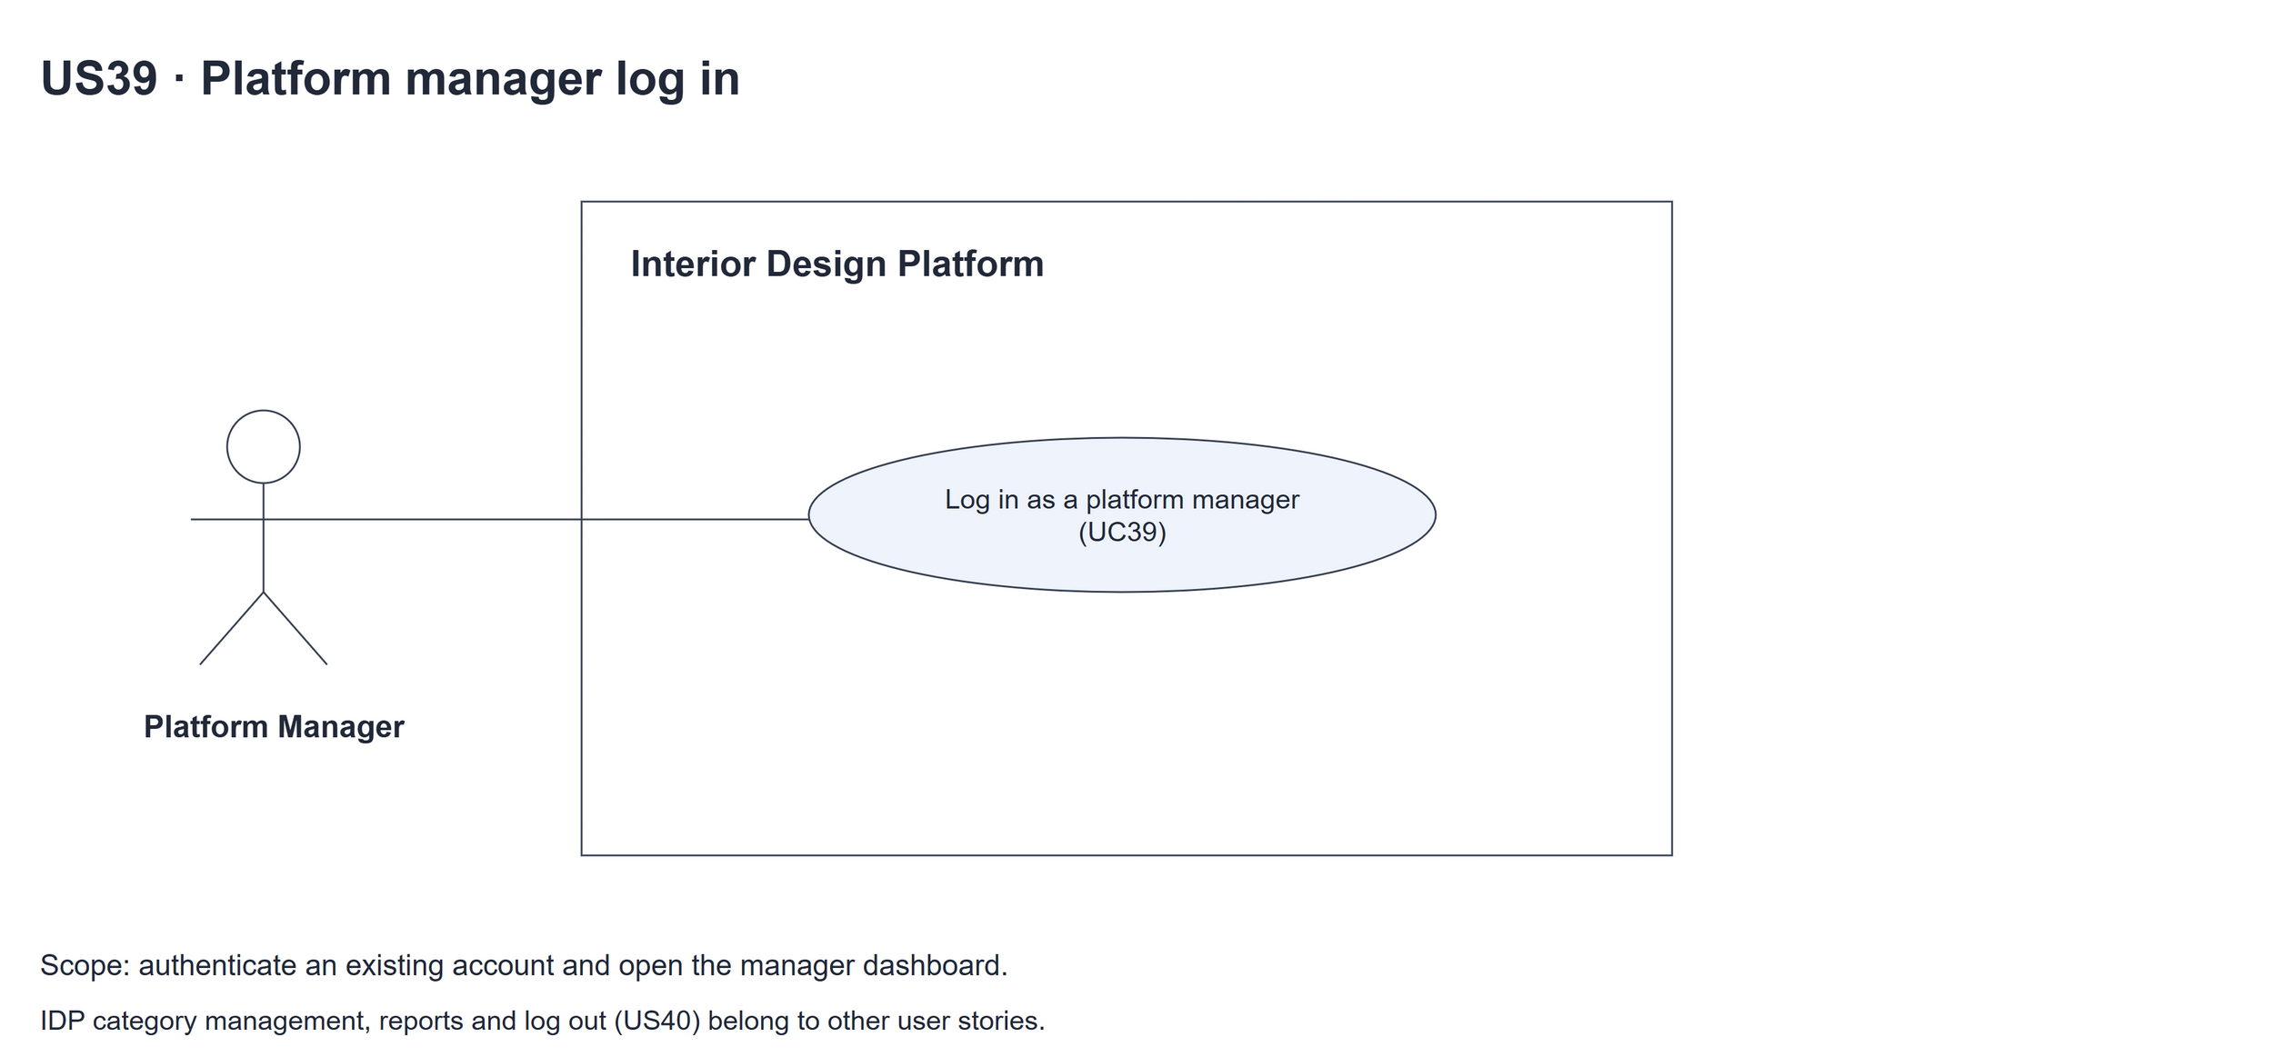
Figure 1: Use case diagram for US39 Platform manager log in

3. Use case description
Use case | UC39 Platform manager log in
Actor | Platform Manager
Brief description | The Platform Manager logs in with their username and password so they can use the manager dashboard.
User story | US39: As a platform manager, I want to log in so that I can manage IDP categories and reports.
Preconditions | The platform manager has a user account made by the User Admin (UC8) whose user profile has the "Manage IDP categories" and "Generate reports" permissions.  The Platform Manager is not logged in.
Trigger | The Platform Manager opens the manager login page.
Basic flow | 1. The Platform Manager opens the manager login page.  2. The system shows the login form.  3. The Platform Manager types their username and password and clicks "Log in".  4. The system checks that both fields are filled in and trims the spaces from the username.  5. The system checks the username and password, that the account and its user profile are Active and that the profile has both manager permissions.  6. The system starts a new session and opens the manager dashboard.  7. The system shows "Welcome back, <username>" with the IDP Categories and Reports cards.
Alternative flows | 4a. A field is empty: the system shows "Please enter your username and password". Back to step 3.  5a. The username or password is wrong, the account or profile is suspended, or the profile doesn't have the manager permissions: the system shows the same message "Invalid login details or access unavailable". Back to step 3.
Postconditions | The Platform Manager is logged in. The session holds userId, profileId and username.  The manager dashboard is shown.

4. Wireframes
The wireframes were drawn in draw.io. They are low-fidelity: they show the layout and the flow, not the final colours. The orange numbers match the notes under each screen.

4a - Log in form
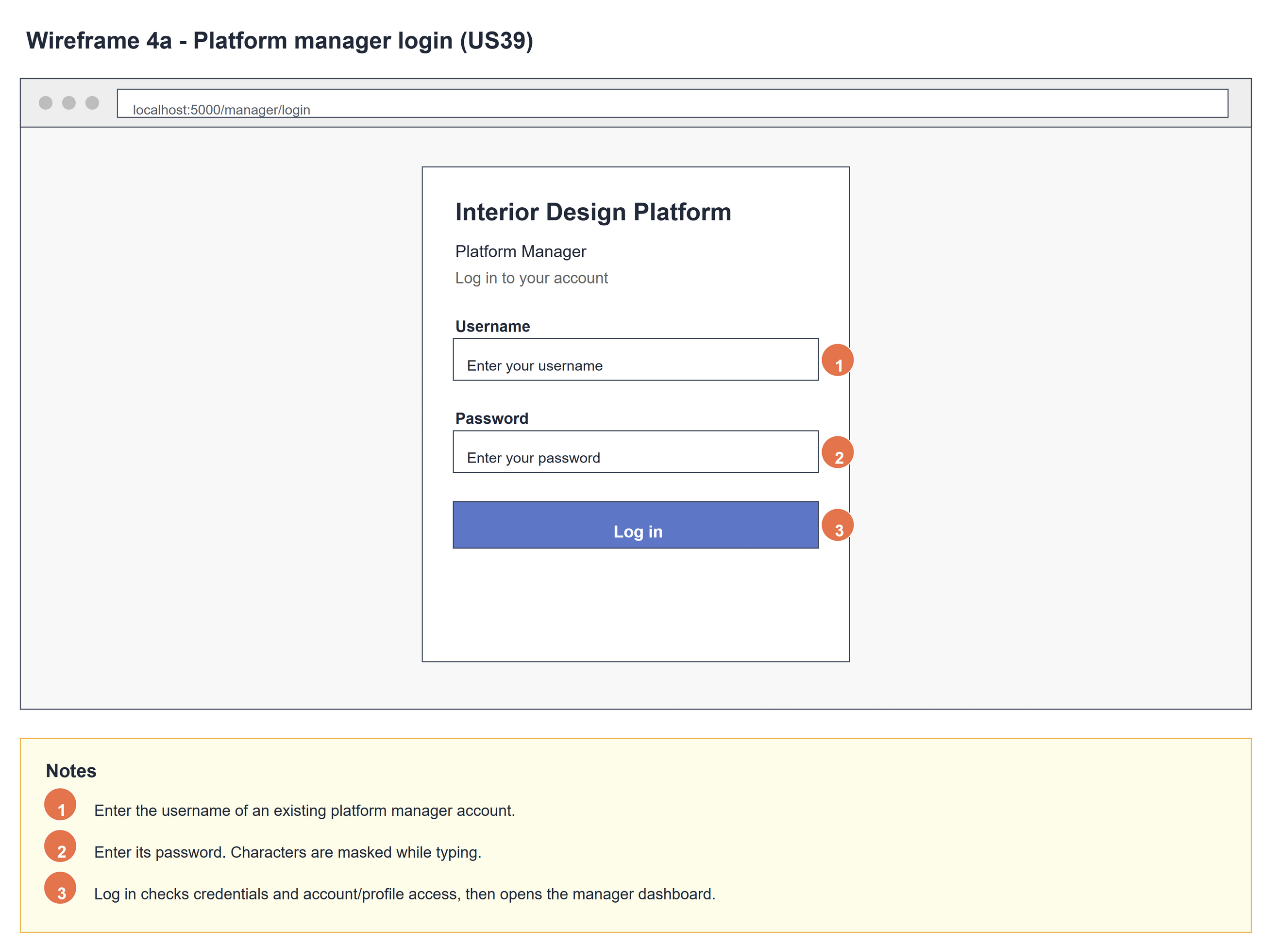
Figure 2: Wireframe 4a - Log in form (US39)

4b - Missing required fields
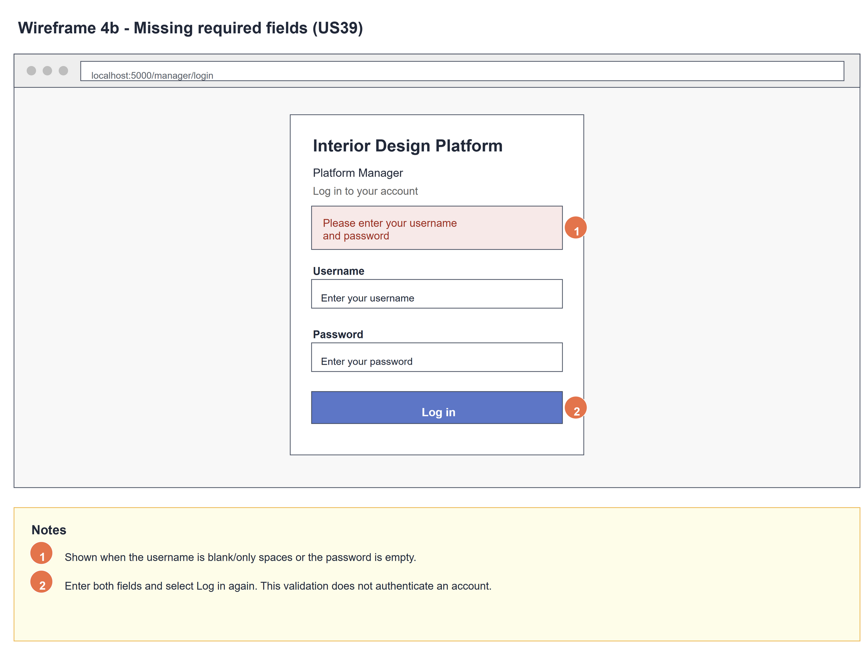
Figure 3: Wireframe 4b - Missing required fields (US39)

4c - Invalid login
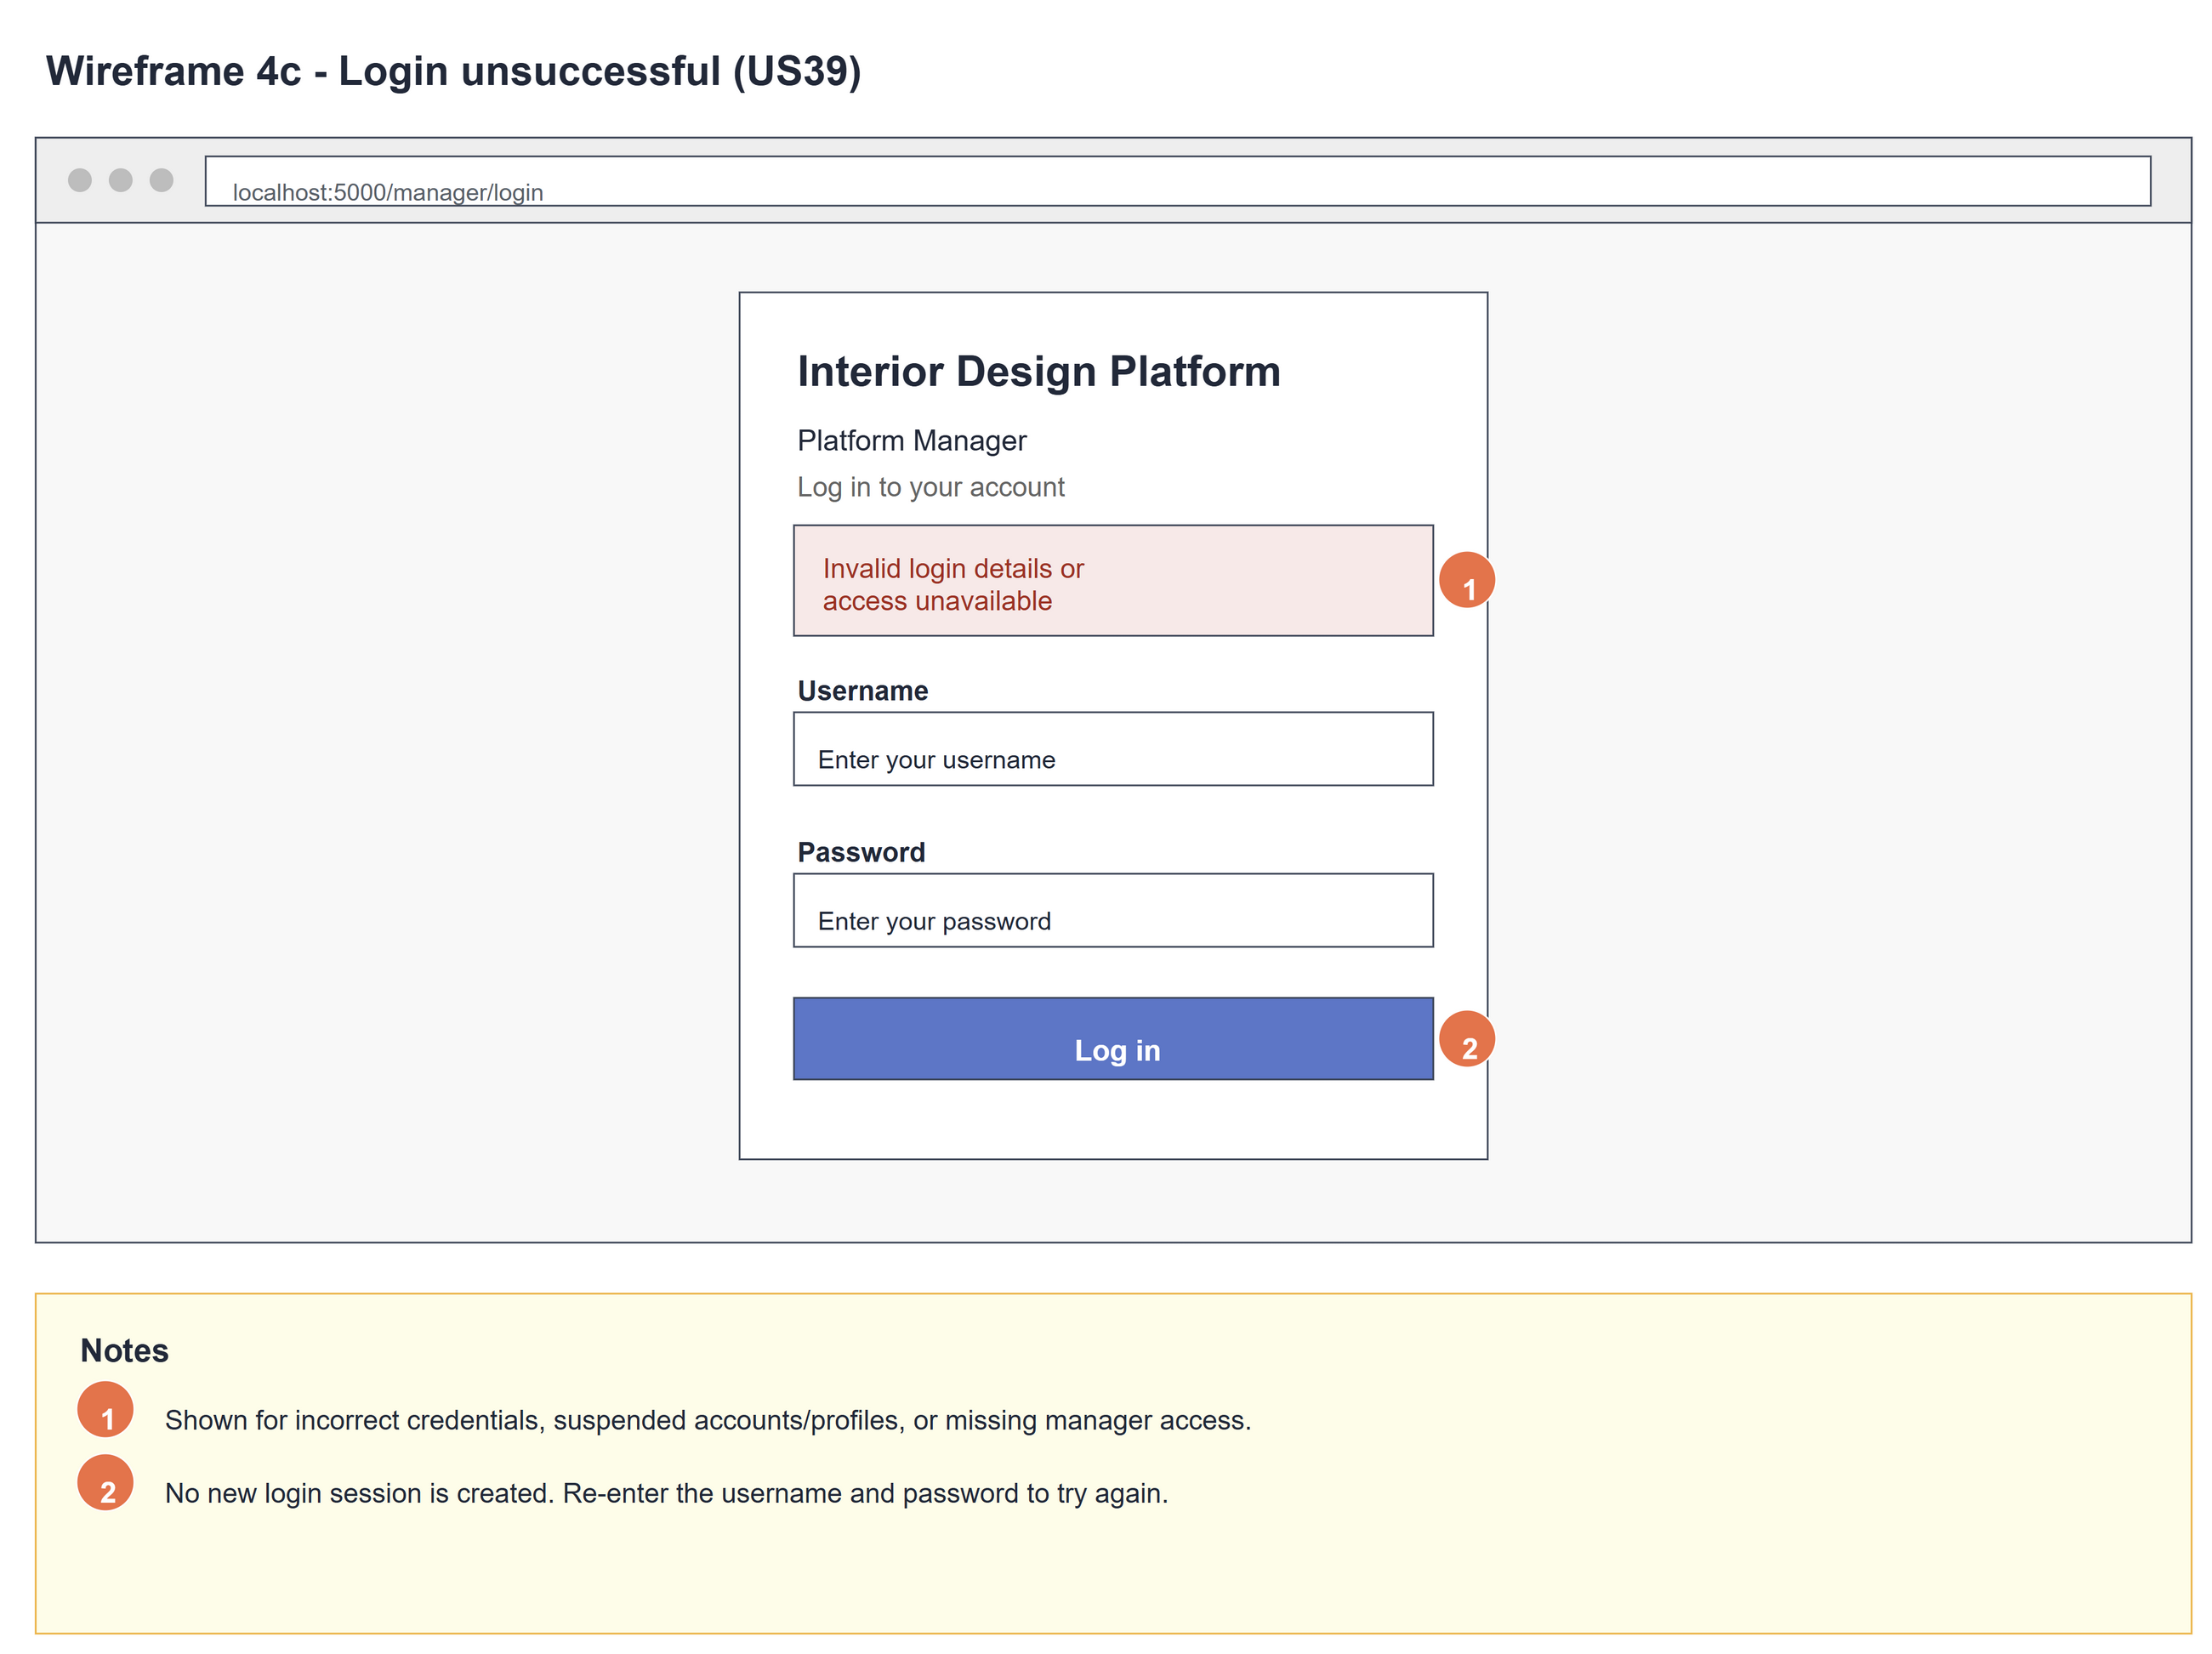
Figure 4: Wireframe 4c - Invalid login (US39)

4d - Manager dashboard
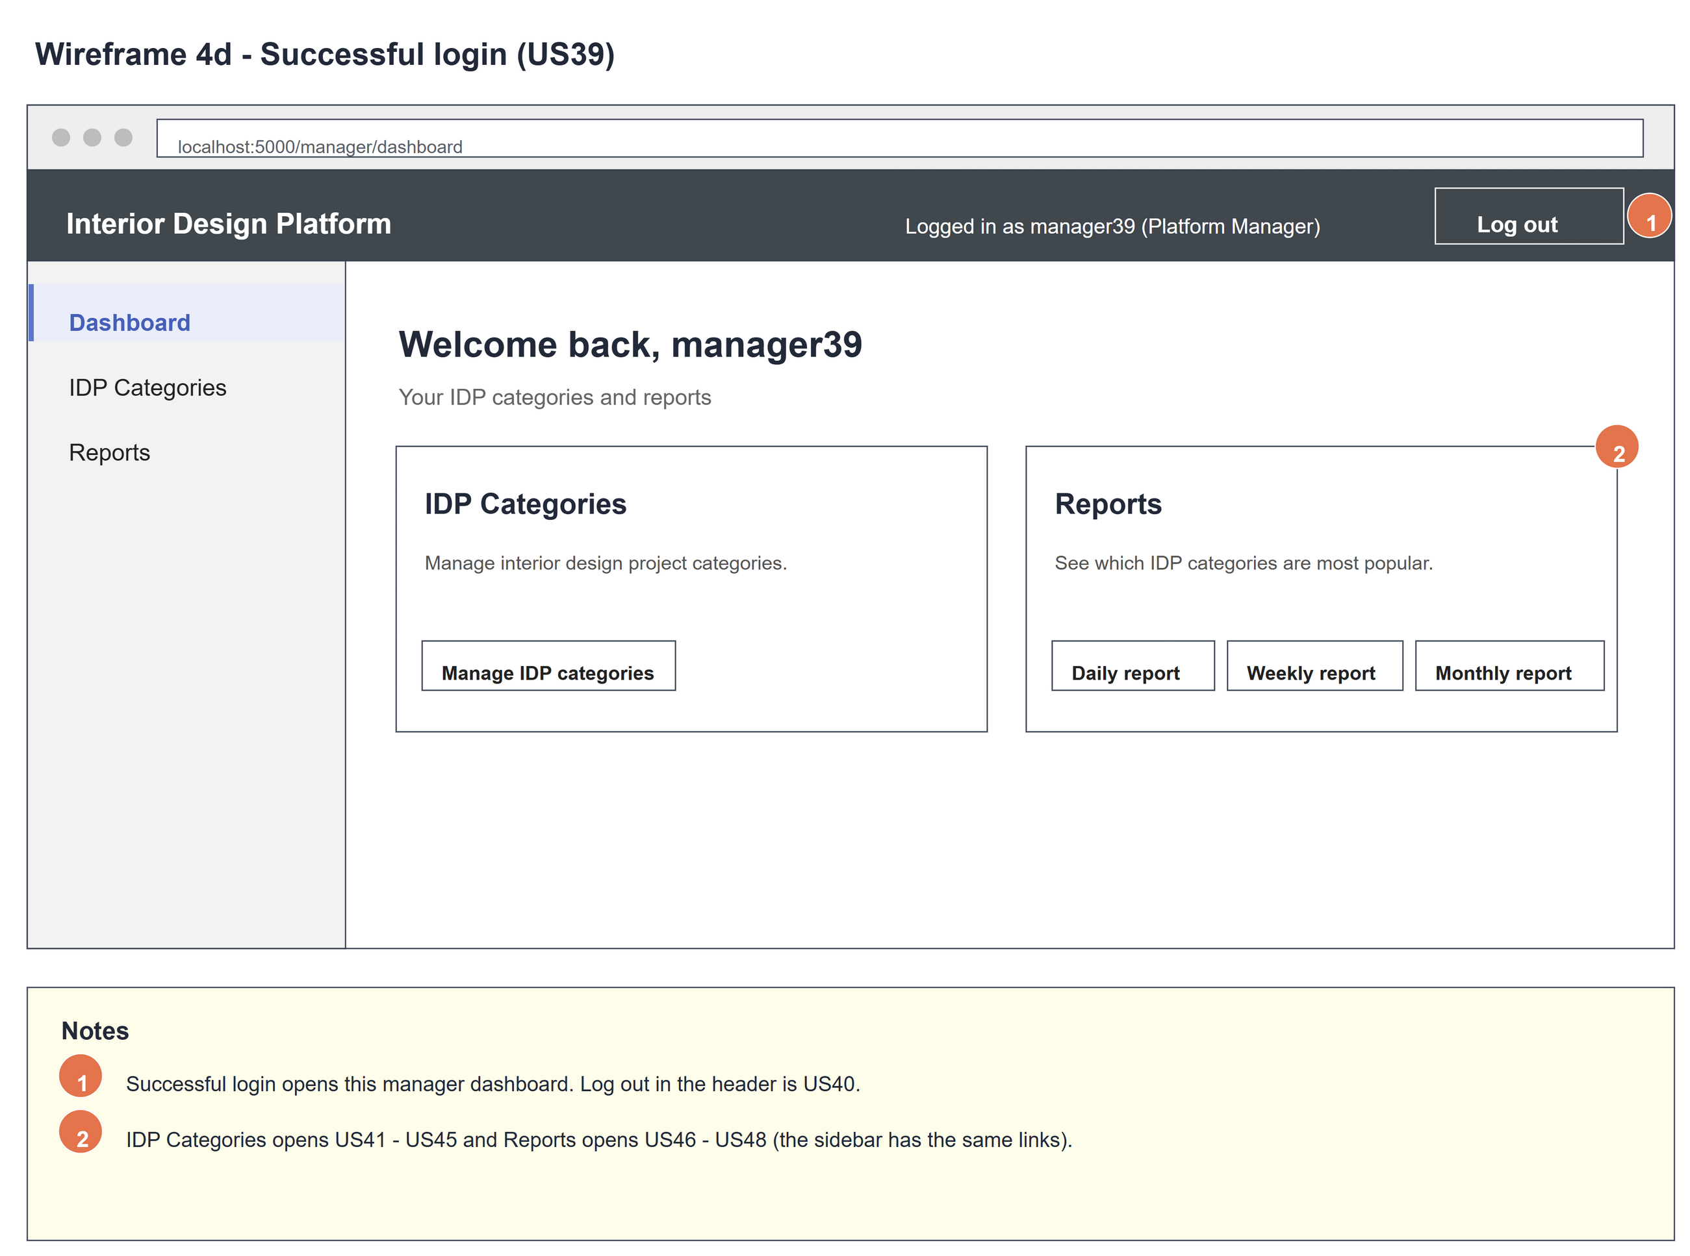
Figure 5: Wireframe 4d - Manager dashboard (US39)

5. B-C-E class diagram
The solid line means the boundary calls the controller. The dashed line means the controller uses the entity class. Only the operations needed for this use case are shown.
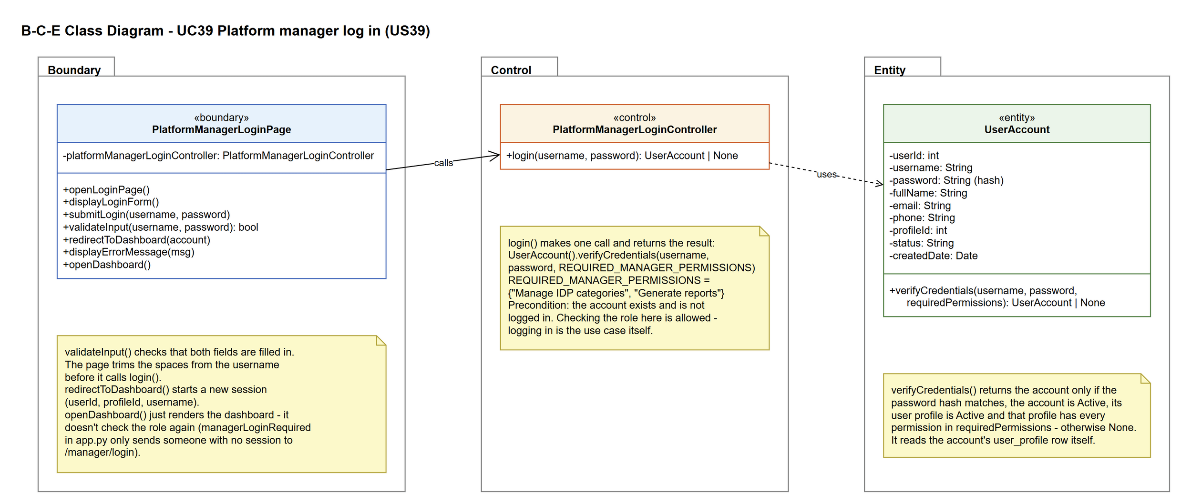
Figure 6: B-C-E class diagram for US39 Platform manager log in
Layer | Class | What it does
Boundary | PlatformManagerLoginPage | The manager login page and dashboard. validateInput() checks both fields are filled in, submitLogin() trims the username and calls login(), redirectToDashboard() starts the session and displayErrorMessage() shows the messages. openDashboard() just renders the dashboard - it doesn't check the role again.
Control | PlatformManagerLoginController | Controller for UC39. login() just calls UserAccount.verifyCredentials(username, password, REQUIRED_MANAGER_PERMISSIONS) and returns the account or None.
Entity | UserAccount | The existing user account (US1). verifyCredentials() returns the account only if the password hash matches, the account is Active, its user profile is Active and the profile has every required permission. It reads the profile row itself, so no UserProfile class is needed here.

6. Sequence diagram
The sequence diagram follows UC39. The page shows the form (step 2) and checks the input when it is submitted (step 4). The outer alt covers alternative flow 4a: an empty field is caught by the page. For filled-in input the page trims the username and calls login(), which makes one call to UserAccount.verifyCredentials() with the manager permissions (step 5). The inner alt shows the two endings: the session is started and the manager dashboard opens (steps 6-7) - openDashboard() just renders it - or the same error message for every kind of failure (alternative flow 5a).
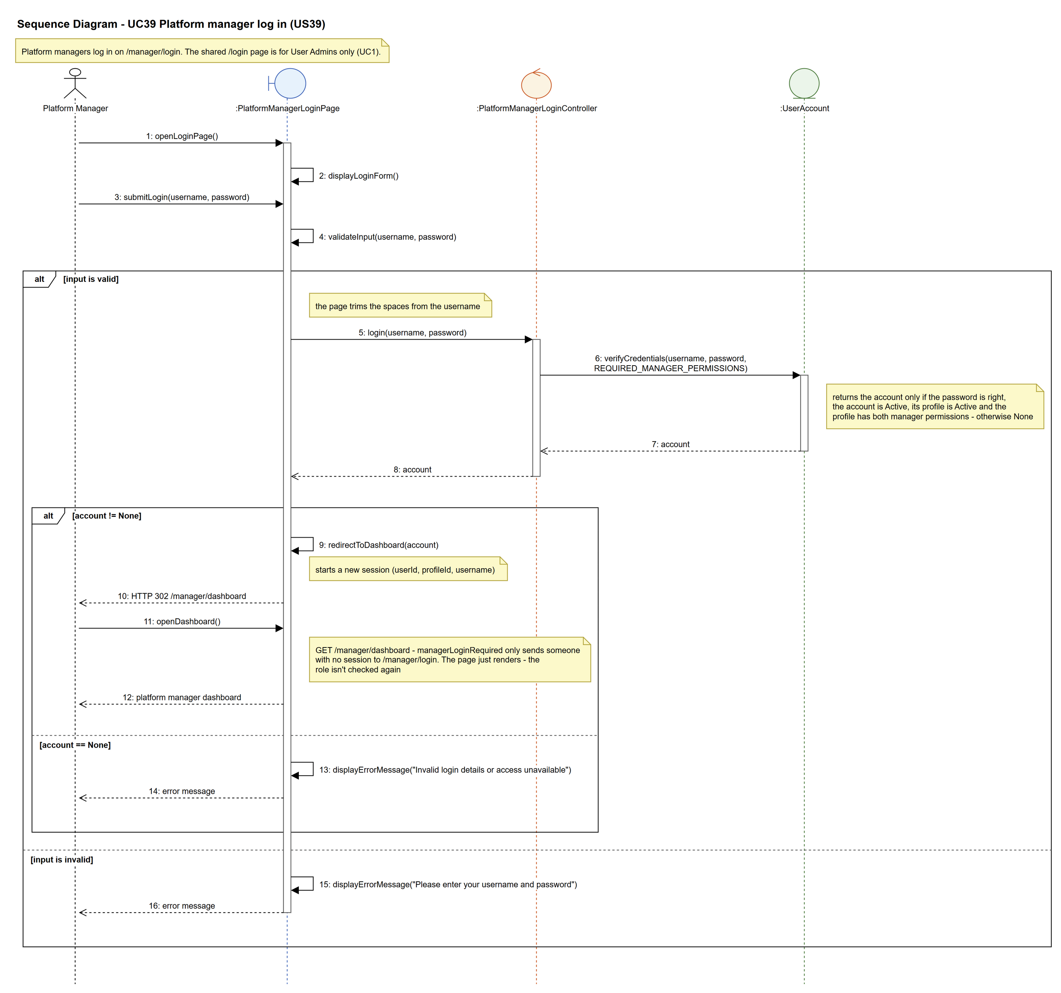
Figure 7: Sequence diagram for UC39 Platform manager log in

7. Test cases
Test data used below (same as database/seedData.py and the test files): user profiles User Admin (id 1), Interior Designer (id 2), Customer (id 3) and Platform Manager (id 4), all Active. User accounts admin01 / Admin@123 (User Admin) and cust001 / Cust@123 (Customer). The manager account manager39 / Manager@123 (Daniel Tan, Platform Manager profile) is made first with UC8.

7a. System test cases (black box)
Equivalence partitioning and boundary value analysis were used to pick the test data. Fill in "Actual result" and "Pass/Fail" after running each test.
Test ID | Scenario | Prerequisites | Test steps | Test data | Expected result | Actual result | Pass / Fail
TC39.1 | Valid manager login | manager39 exists and is Active. | 1. Open /manager/login  2. Type the username and password  3. Click "Log in" | manager39 / Manager@123 | Manager dashboard with "Welcome back, manager39" and the IDP Categories and Reports cards.
TC39.2 | Both fields empty | None. | 1. Open /manager/login  2. Leave both fields empty  3. Click "Log in" | (empty) / (empty) | "Please enter your username and password". Not logged in.
TC39.3 | Wrong password | manager39 exists. | 1. Open /manager/login  2. Type the wrong password  3. Click "Log in" | manager39 / Wrong@123 | "Invalid login details or access unavailable". Not logged in.
TC39.4 | Suspended account | manager39 has been suspended (UC11). | 1. Open /manager/login  2. Type the details  3. Click "Log in" | manager39 / Manager@123 | "Invalid login details or access unavailable". Not logged in.
TC39.5 | Not a platform manager | designer13 exists. | 1. Open /manager/login  2. Log in as a designer | designer13 / Design@123 | "Invalid login details or access unavailable". Not logged in.
TC39.6 | Shared login page refuses a manager | manager39 exists. | 1. Open /login  2. Log in as manager39 | manager39 / Manager@123 | "Invalid login details or account suspended" - /login is for User Admins only (UC1). Not logged in.
TC39.7 | Dashboard without logging in | Not logged in. | 1. Open /manager/dashboard | - | Sent to the manager login page.
TC39.8 | Manager can't get a User Admin session | manager39 exists. Not logged in. | 1. Log in on /login as manager39  2. Open /accounts | manager39 / Manager@123 | The login on /login is refused, so /accounts sends them to /login.
TC39.9 | Spaces around the username | manager39 exists and is Active. | 1. Open /manager/login  2. Type the username with spaces around it  3. Click "Log in" | " manager39 " / Manager@123 | The manager dashboard opens (the page trims the spaces). | The manager dashboard opened (the username was trimmed). | Pass

7b. Unit test cases (for TDD)
These are written before the code (test-driven development) and run with pytest (python -m pytest). They cover normal inputs, abnormal inputs and boundary values. Each one matches a test function in tests/test_us39_platformManagerLogin.py (UT39.1 is test_ut39_1_...). "Pass" is from the pytest run on 9 November 2026.
Test ID | Class and method | Input / setup | Expected output | Type | Pass / Fail
UT39.1 | PlatformManagerLoginController.login() | "manager39", "Manager@123" | Returns the account (username manager39, profileId 4) | Normal | Pass
UT39.2 | PlatformManagerLoginController.login() | "manager39", "Wrong@123" | Returns None | Abnormal | Pass
UT39.3 | PlatformManagerLoginController.login() | "nobody13", "Manager@123" | Returns None | Abnormal | Pass
UT39.4 | PlatformManagerLoginController.login() | manager39 with the account suspended | Returns None | Abnormal | Pass
UT39.5 | PlatformManagerLoginController.login() | manager39 with the Platform Manager profile suspended | Returns None | Abnormal | Pass
UT39.6 | PlatformManagerLoginController.login() | "admin01", "Admin@123" (User Admin) | Returns None | Abnormal | Pass
UT39.7 | PlatformManagerLoginController.login() | "cust001", "Cust@123" (Customer) | Returns None | Abnormal | Pass
UT39.8 | PlatformManagerLoginController.login() | Profile only has "Manage IDP categories" | Returns None (both permissions needed) | Boundary | Pass
UT39.9 | UserAccount.verifyCredentials() | "manager39", "Manager@123", REQUIRED_MANAGER_PERMISSIONS | Returns the account. The saved password is a hash, not "Manager@123" | Normal | Pass
UT39.10 | PlatformManagerLoginPage.validateInput() | "", "Manager@123" | Returns False | Boundary | Pass
UT39.11 | PlatformManagerLoginPage.validateInput() | "manager39", "" | Returns False | Boundary | Pass
UT39.12 | PlatformManagerLoginPage.validateInput() | " " (spaces only), "Manager@123" | Returns False | Boundary | Pass
UT39.13 | PlatformManagerLoginPage.validateInput() | "manager39", "Manager@123" | Returns True | Normal | Pass
UT39.14 | PlatformManagerLoginPage.openLoginPage() | GET /manager/login | Page shows "Platform Manager" and the username and password fields | Normal | Pass
UT39.15 | PlatformManagerLoginPage.submitLogin() | POST manager39 / Manager@123 | Redirects to /manager/dashboard. Session has userId, profileId 4 and username, but no password | Normal | Pass
UT39.16 | PlatformManagerLoginPage.submitLogin() | POST manager39 / Wrong@123 | "Invalid login details or access unavailable". No userId in the session | Abnormal | Pass
UT39.17 | PlatformManagerLoginPage.submitLogin() | POST empty username and password | "Please enter your username and password" | Boundary | Pass
UT39.18 | PlatformManagerLoginPage.submitLogin() | POST with the account suspended | "Invalid login details or access unavailable". No userId in the session | Abnormal | Pass
UT39.19 | PlatformManagerLoginPage.openDashboard() | Logged in as manager39 | "Welcome back, manager39", IDP Categories and Reports. No "User Accounts" | Normal | Pass
UT39.20 | managerLoginRequired (app.py) | GET /manager/dashboard, not logged in | Redirects to /manager/login | Abnormal | Pass
UT39.21 | PlatformManagerLoginPage.openDashboard() | Profile suspended after logging in | The dashboard still opens (HTTP 200) - the role isn't checked again. The next login is refused | Abnormal | Pass
UT39.22 | loginRequired (app.py) on /accounts | manager39 tried the shared /login (no session there) | Redirects to /login | Abnormal | Pass
UT39.23 | LoginPage.submitLogin() (shared /login) | POST manager39 / Manager@123 | "Invalid login details or account suspended" (/login is for User Admins only). No userId in the session | Abnormal | Pass
UT39.24 | LoginPage.submitLogin() (shared /login) | POST admin01 / Admin@123 | Redirects to /dashboard and /accounts still opens | Normal | Pass
UT39.25 | loginRequired (app.py) on /dashboard | manager39 tried the shared /login (no session there) | Redirects to /login | Abnormal | Pass
UT39.26 | PlatformManagerLoginPage.redirectToDashboard() | Old data in the session before logging in | The old session is cleared after logging in | Normal | Pass
UT39.29 | PlatformManagerLoginController.login() | custom39 in a "Reporting team" profile with both manager permissions | Returns the account | Normal | Pass
UT39.30 | PlatformManagerLoginController.login() | designer39 (Interior Designer profile) | Returns None | Abnormal | Pass
UT39.31 | UserAccount.verifyCredentials() | "admin01", "Admin@123", REQUIRED_MANAGER_PERMISSIONS | Returns None (the User Admin profile doesn't have both manager permissions) | Abnormal | Pass
UT39.32 | PlatformManagerLoginPage.submitLogin() | POST " manager39 " / Manager@123 | The page trims the username: redirects to /manager/dashboard | Boundary | Pass

